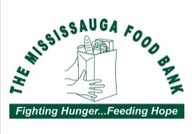
Scouts Canada
(6th Erin Mills and 4th Erindale Mississauga)

FOOD DRIVE

SUNDAY, May 5th

Please place non-perishable food donations in this bag and leave outside your front door
By Noon on May 5th
Please ensure the flyer is visible from the sidewalk
In case of rain, please put the donation inside a plastic bag
For monetary donations directly to Mississauga Food bank please scan the QR Code below

Did you know?
39% of Food Bank’s clients are kids
20% of clients are single parents

We are projecting 8% of Mississauga’s population will turn to a food bank by May 2024, your support is needed more than ever

Most Needed Items
Peanut Butter, Cereal, Tuna, Canned Fish or Meat, Baby Food & Formula, Mac & Cheese, Canned Fruit or Vegetables

Our group does its best to pick up every donation but sometimes we miss one. If your donation hasn’t been picked up by 3:00 PM, please drop it off at 4544 Eastgate Parkway, Mississauga ON, L4W 3W6

Questions: email us at 6thEMScouts@gmail.com

Kids join Scouts for amazing experiences they can’t find anywhere else. Scouts is the start of something great. Find out how to become a Scout today!
REGISTER ONLINE TODAY! Scouts.ca | 1-888-855-3336

